|  |  |
| --- | --- |
| **NAMA** | **: HENDRA USMAN** |
| **NIM** | **: D0221079** |
| **KELAS** | **: INFORMATIKA - F** |
| **MATA KULIAH** | **: PEMROGRAMAN WEB 1** |

**Elemen-Elemen <Form> HTML:**

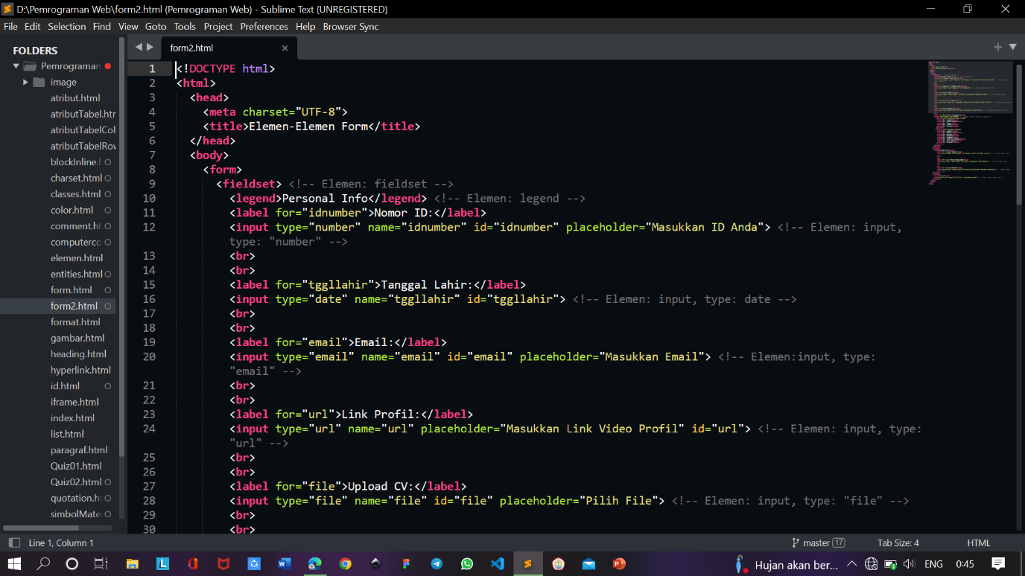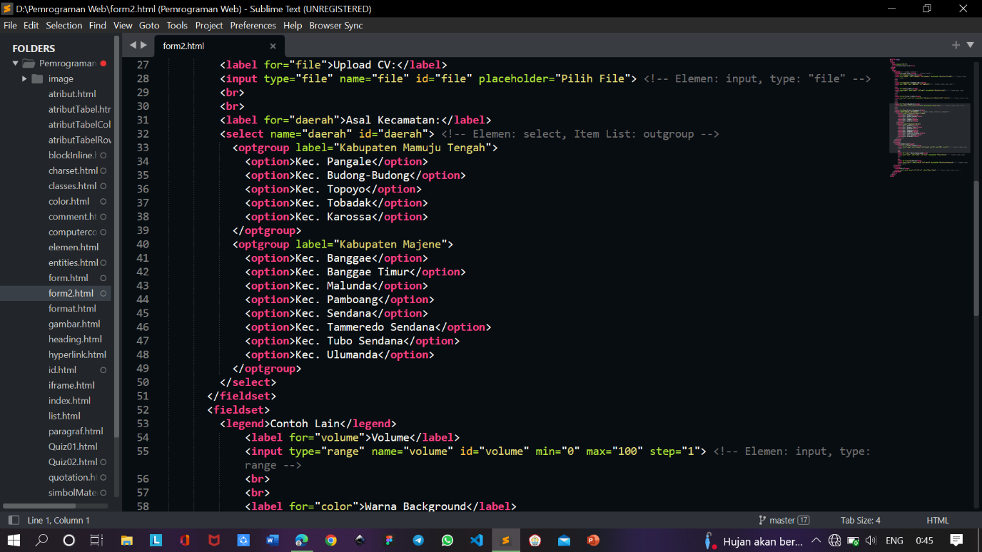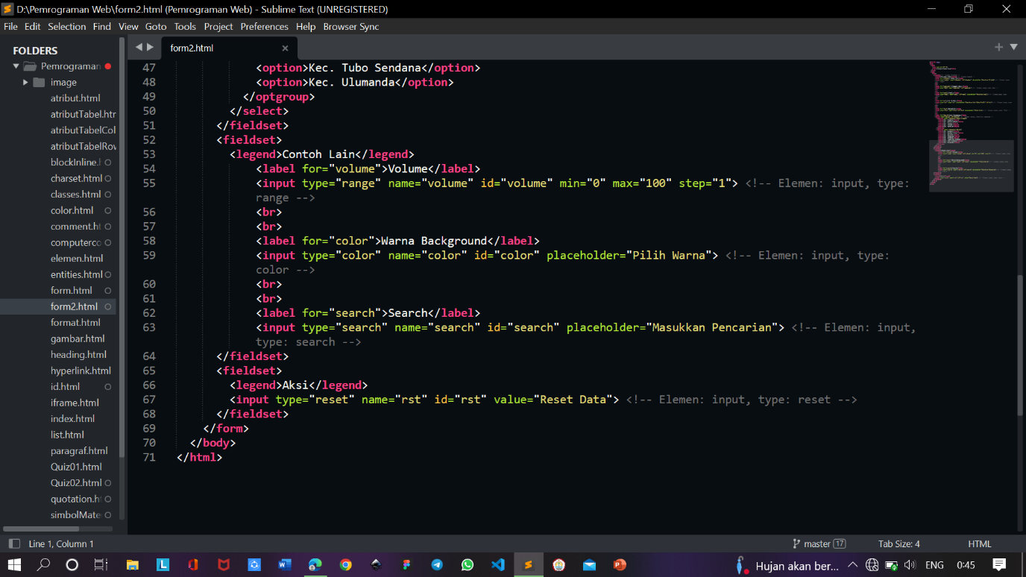

**Output: - Dijalankan di Browser**

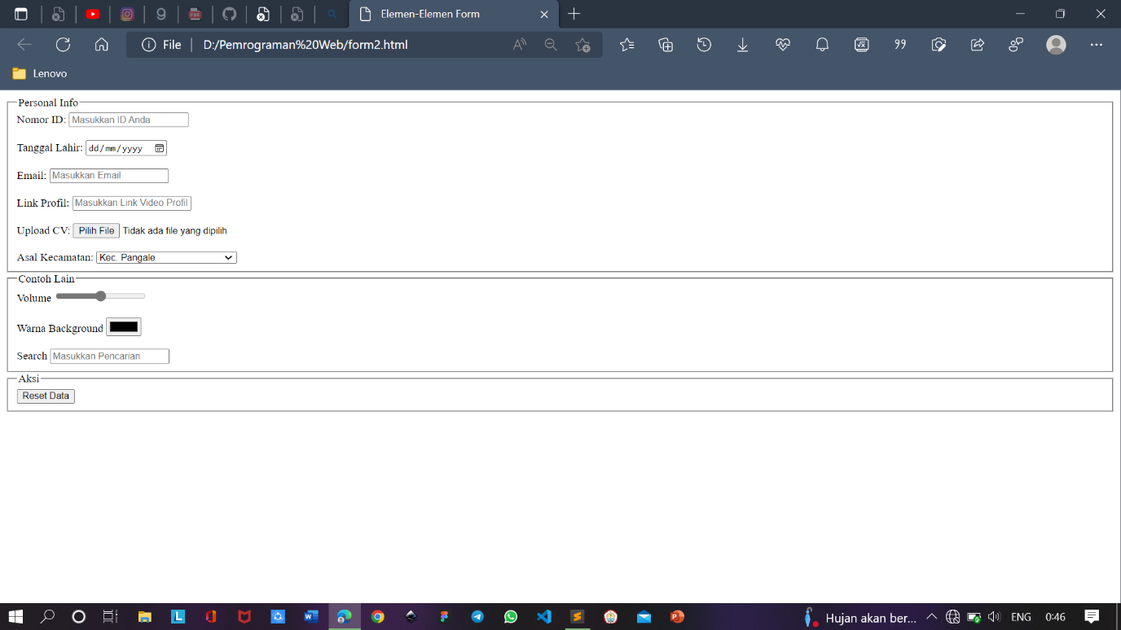

**Output: - Dijalankan di Browser, lalu menginput data**

